User Access Request for Windchill GPDM

Contents
1. QuickService Ticket creation 1
2. Ticket Request category 2
2.1 EMEA, LA and AP Access Request 3
2.2 NA Access Request 10
3. Container to Role approval from CA 15
4. User communication template 16
5. Checklist for AMS team 17

QuickService Ticket creation
User creates request via QuickService portal:
URL : https://qservice.intra.fmeone.com/servicedesk/customer/portals
Once user opens the URL, below page appears, user will select GPDM Windchill portal to create requests.
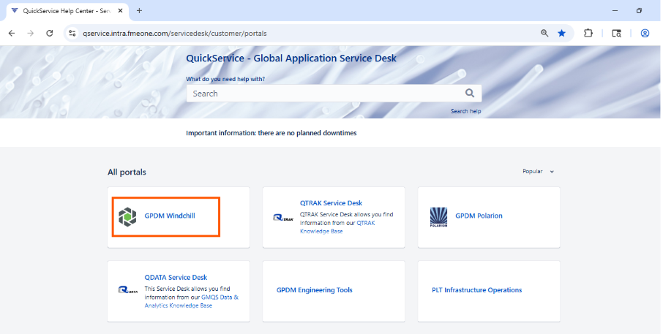

Ticket Request category
Various categories of requests will be displayed.
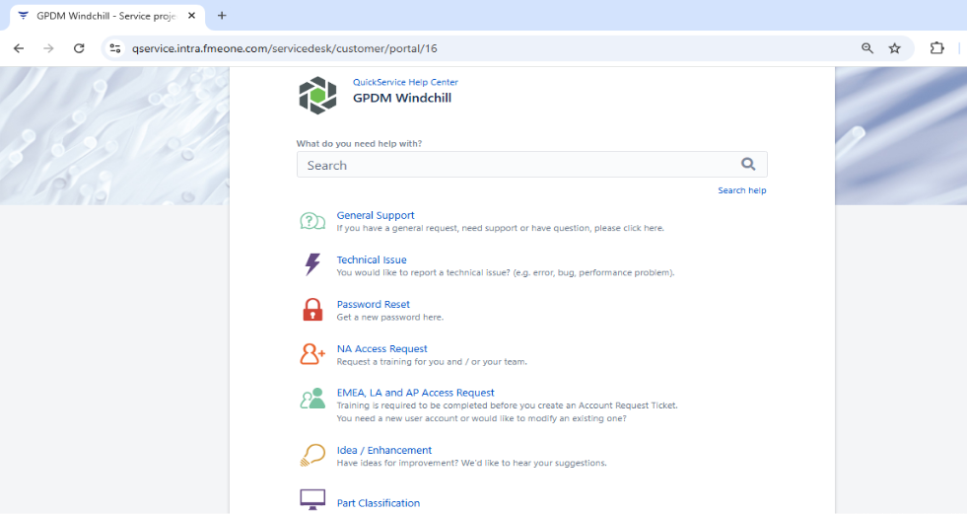

2.1 EMEA, LA and AP Access Request

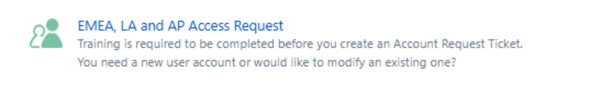

Users will be able to see below page:
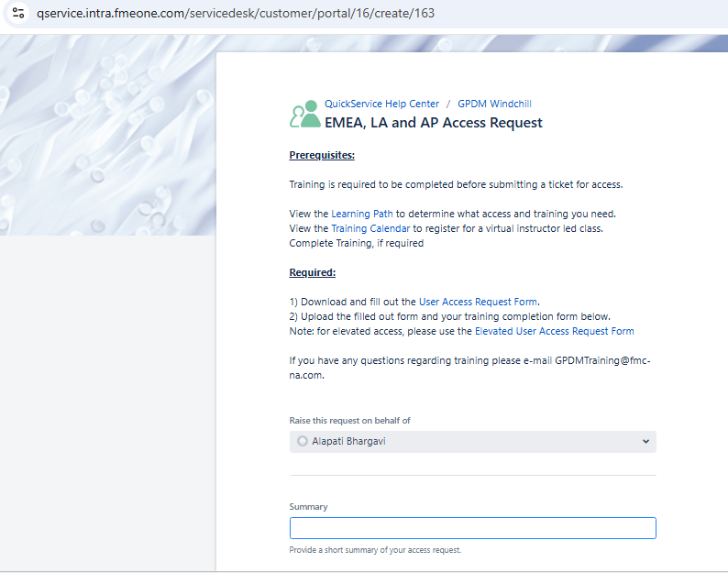
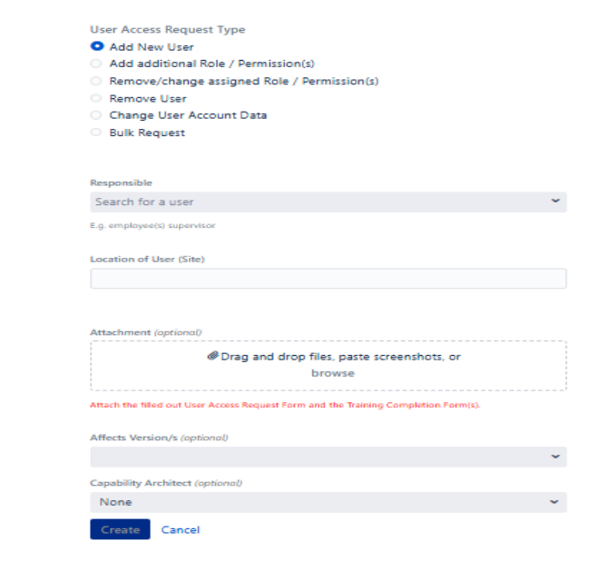

Fields/Attributes values:
- Raise this request on behalf of – By default, the requestor’s name appears here or someone who can’t access the URL then their other team member needs to create on behalf of them.
- Summary - Provide a short summary of your access request.
- User Access Request Type - Select the required action item for the request
- Add New User
- Add additional Role / Permission(s)
- Remove/change assigned Role / Permission(s)
- Remove User
- Change User Account Data
- Bulk Request
- Responsible - employee or supervisor
- Location of User (Site) - Location of the user will be selected
- Attachment (optional) – Though the name says optional, it isn’t. User must attach the filled-out User Access Request Form and the Training Completion Form(s)
- Affects Version/s (optional) - Windchill latest release w.r.t. Fresenius needs to be selected (currently it is 8.0)
- Capability Architect (optional) - the dropdown contains all the capability architects’ names for different modules as mentioned in below table -
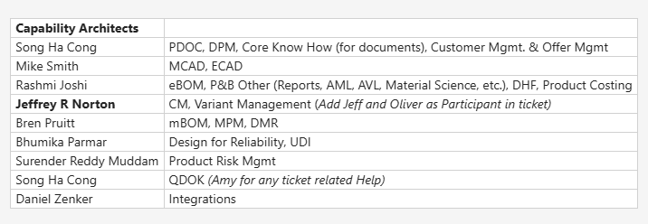
- Click on the Create button - Ticket gets created.

- Training is required to be completed before submitting a ticket for access.
View the Learning Path to determine what access and training users need.
Below are the additional links for the training purpose:
- https://bluespace.fmeone.com/spaces/GlobalPDM/pages/283768310/EMEA+LA+AP+Training+Matrix
- https://bluespace.fmeone.com/pages/viewpage.action?pageId=325035676&spaceKey=KBGPTA&title=QRG%2Bfor%2BUser%2Baccess%2Bmanagement%2Bin%2BWindchill
- User can complete the self-paced training certificates by following below link -
https://bluespace.fmeone.com/spaces/GlobalPDM/pages/31706694/Training+Reference+Guides
- User to complete the form and update the ticket.
- The support team needs to verify the certificate and assign the required roles.
- Training calendar users can sign up and get the certificate
- If no training is available in upcoming days based on user requirement we can discuss with CA and CA will schedule the training to user.
- To attend instructor-led sessions, you can sign up directly via BlueSpace for Windchill. Everything is centralized there for easy access.
https://bluespace.fmeone.com/spaces/GlobalPDM/pages/64496300/Engineering+Capability+Training+Calend…
(EMEA Requests):
- Ask the user to enroll for the training via the training calendar.
- Request them to submit the training certificate upon completion.
- Verify the certificate, assign the appropriate roles, and notify the user.
- Repeat the process until all required training is completed, and roles are assigned.
- Once all requested roles are assigned, inform the user and close the ticket.
Suggestion:
For EMEA REGION
If the user has not provided training evidence and is not yet enrolled in the required training, we should advise them to enroll and complete the training and should proceed with ticket closure and inform user to create a new ticket once training is completed and user has training evidence.

Note: If the user is unsure about training enrollment, the AMS team should assist them in the process.
- Download and fill out the UACF Form based on requirements of roles needed in the system.
- User Access Request Form
- Elevated User Access Request Form
UACF Form looks like this:
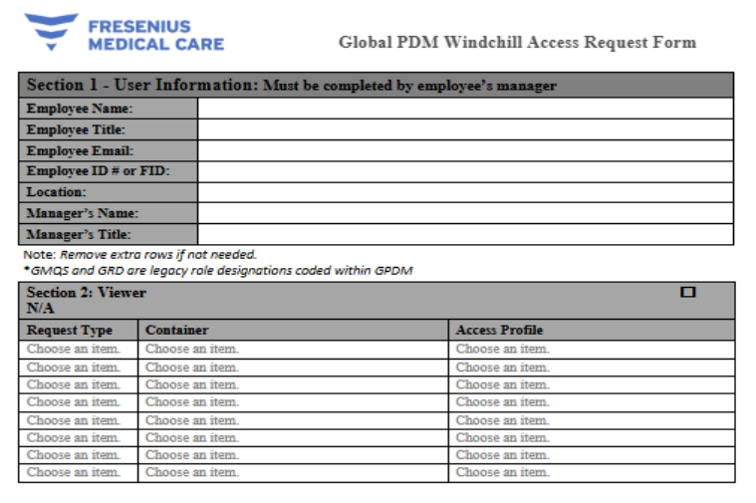
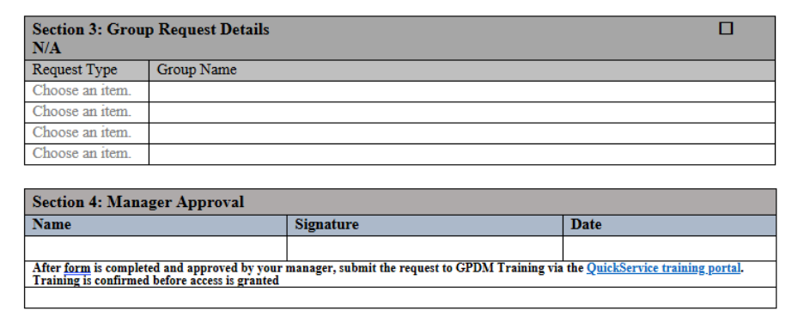
Users must fill out Elevated UACF Form if the roles below are needed to be added in the system.
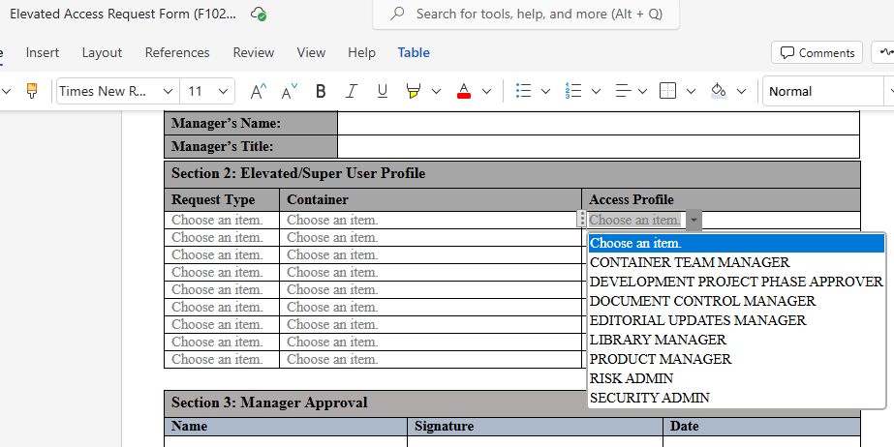
- User must select the roles based on the respective capability, then only the access will be provided by the support team.
- <Add the role mapping table and BlueSpace link>
- URL: WIP___EMEA, LA & AP Training Matrix.xlsx
- https://bluespace.fmeone.com/spaces/GlobalPDM/pages/283768310/EMEA+LA+AP+Training+Matrix#EMEA,LA&APTrainingMatrix-WindchillLearningPathEMEA,LA&AP
- <UACF roles are updated as per latest configuration / release>
UACF has updated with latest configuration, but we identified few containers still not updated
- Present in latest UACF – No roles to be provided to any user – Not in Use containers: Catalogue Items - NA and Catalogue Items – RoW.
- Therapy System - In Home" was renamed as "PD Therapy System".
- Multi Global Platform was renamed as Multi Global Machine.
- Materials Library – Heart & Lung Product is a new container to be added in the UACF.
- Users can request group access in the UACF Form (Group Request details).
Users need to share the UACF along with manager approval, then only it's valid.
- Upload the filled-out form and your training completion form below. If you have any questions regarding training, please e-mail GPDMTraining@fmc-na.com.
- License Mapping File based on roles assigned to user:
URL: Role_LicenseGroup_Mapping_cheat_sheet.xlsx

2.2 NA Access Request
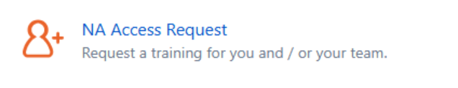
- User will select NA Access Request Type & able to see the Page below:
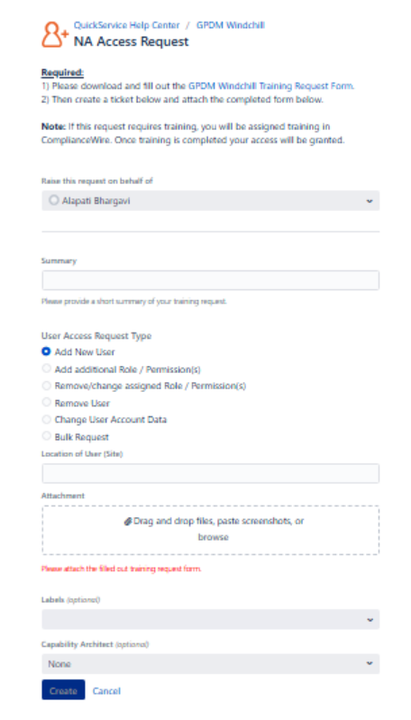
- Please download and fill out the GPDM Windchill Training Request Form
- Then create a ticket and attach the completed form.
Note: If this request requires training, the user will be assigned training in ComplianceWire. Once training is completed, user access will be granted.
Fields/Attributes values are like EMEA request type; user needs to select according to the requirement.
NA Access Reference Document:
URL: Work Instructions - NA.pdf

(NA Requests):
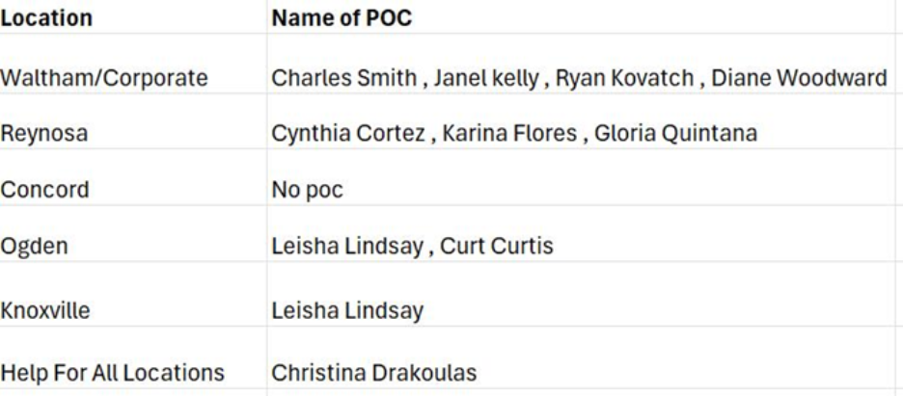
Note:
- For locations not listed, assign it to Christina Drakoulas.
- Since Lawrence & Lexington is part of the Waltham region, requests from Lawrence & Lexington should be assigned to the Waltham POCs.
- Karina Flores/Diane Woodward/Ryan Kovatch/Curt Curtis- They are not the POCs anymore (Latest Sheet to be shared by Gayathri)
User Training and Access Provisioning Process for NA region

Tickets related to user access for the NA region will be assigned to the AMS Team. Roles will be provisioned according to the UACF form. If a requested role requires mandatory training and the user has not yet completed it, we will follow the process outlined below.
- Assign the ticket to the Regional POC, add them to the Request Participant section, and add an internal note informing the POC about the required user training. Move the ticket to “Waiting for support” state.
[NOTE: Don’t resolve the ticket when training is yet to be completed by user]
- Once the user completes the required training, the POC will assign the ticket back to the AMS team, move it to “In Progress” state, and attach the relevant training evidence.
- Review the attached training evidence and assign the necessary roles. If any training is still pending, follow Step (1).
- Continue this process until all required training is completed, and all requested roles have been assigned.
- After confirming that all training is complete and the user has all required roles, inform the user and resolve the ticket.
- Suggestion:

- For the NA & EMEA Regions, if a user requires training completion and the process is taking longer than expected, we recommend introducing a new state specifically for capturing the user’s response. This state will ensure that the information is easily accessible and can be managed more efficiently.

- If no training is available in upcoming days based on user requirements, we can discuss with CA and CA will schedule the training to user.
Confirmation from CA’s is required - procedure to follow for groups access to be assigned to users
In most previous tickets, the earlier team granted group access by simply verifying the groups and obtaining the Manager’s signature on the UACF. However, for a couple of recent tickets, the CAs have asked the team to reach out to them before providing access. This has caused confusion within the team, and we need clarification on the process for group access requests.

Additional Points:
Role | Required Action Item
Risk Analysis Author or Approver | - The user must be a part of the following three libraries. The user will be assigned a Risk Viewer role in these libraries:  * PRM_Global_Library  * Product Risk Mgmt. - Library (EMEA)  * Product Risk Mgmt. - Library (NA)  - For the libraries mentioned above, only the Risk Analysis Viewer and Risk Analysis Admin roles should be assigned.  - If a user has completed Risk Author training, they can be granted the Risk Viewer role without requiring a training certificate.  - In 5008 container if someone is requesting Risk Author role, Risk manager approval is required. (For other containers, we will receive mail from Christina)
Deliverable planning manager (DPM) | Whenever a DPM role is requested, the user is granted Viewer access in the GPLM Product Template Container.
AML/AVL information if user requested | To view the AML/AVL information - needs Vendor Part Author and Manufacturer Part Author roles. AVL info can be seen with the Vendor Part Author and AML info with the Manufacturer Part Author role. For Training certificates Please Contact Andreas Luebbecke or Michael Ohmert to get the required Training certificates.
Costing Author Role | There is no official training available. Please contact Rashmi if you receive any related requests.
Core Member role | Please reach out to the security administrator role for the respective container for core member role assignment.  In case of no users holding the Security Administrator role in a container, please tell the user to directly contact (anita.kirchner@freseniusmedicalcare.com) Anita Kirchner.  Anita is the GTO (Global Topic Owner) for Core Know How (if aforementioned role is not used in a container, it is likely that Core Know How has not been introduced in that container yet).
Effectivity Manager Role | If user requests for Effectivity Manager role in containers, user should also be provided with ESI User group for integrations to work.

Container to Role approval from CA
URL: Role-to-container mapping - To be approved by CA.xlsx
{Roles not to be provided to any user in containers in system as advised by CA}

User communication template
The template is to be used to communicate with the user after successfully creating a new account:
Subject: User created and password generated.
Hello <Username>,

You have been granted access to the Global PDM system and below are the required details:
URL: https://plm.wc.gpdm-euc1.fmcglobal.net/Windchill/app/#ptc1/homepage
Your login/username is: <Username>
Your temporary password: <Password>

Please be aware that your GPDM password is not synchronized with other systems (until further notice)!

Please update your password in GPDM by following the instructions in the attachment below:
URL: Steps to change Password.pdf
Please note that following browsers are supported/compatible with GPDM Windchill:
- Internet Explorer
- Firefox
- Chrome

For any further Question/Issues, please create a ticket following below link:
QuickService Help Center - Service project

Thanks,
Global support Team

Checklist for AMS team
- Open QuickService Portal and select GPDM Windchill.
- Choose the correct request type (EMEA/LA/AP or NA)
- Complete required training (self-paced or instructor-led).
- Download and fill User Access Request Form and Training Completion Form.
- Attach forms to the ticket.
- Select request type (Add User, Add/Remove Role, etc.).
- Submit the request.
- Support team verifies ticket details – request type, Capability Architect tagged, module mapping, ticket priority.
- Support team verifies training and assigns roles.
- For NA: Assign to POC, verify training evidence, and coordinate with AMS.
- Notify user, get acknowledgement and close ticket once roles are assigned properly.

